**Acknowledgements**

We take this opportunity to express our profound gratitude and deep regards to our internship supervisor Mr Rami Rouini for his exemplary guidance, monitoring and constant encouragement throughout the course of this internship.

We would like to express our heartfelt gratitude to Dr. Maha Khemaja, our professor, for her kind support and inspiration which has immensely strengthened our confidence during our internship program.

Finally, we would like to thank the administrative body for their contribution to the success of our graduate studies.

Chapter 1: Project framework

1. **Project framework**

The following project was carried out as part of an end-of-studies internship in order to obtain a “Basic License in Computer Science” diploma.

This internship lasts four months, and was carried out in the company "Pipeline studio".

The goal of this project was to design and produce a 3D video game.

This report details the journey taken throughout the project, going from game analysis

similar until the realization part.

1. **Company presentation**

 Pipeline studio provides virtual services that includes mobile games and mini-games, personalized video games, 3D modelling, VR and AR products, 3D films, trailers and announcements,

**Figure 1 PIPELINE logo**

2D animations as well as training sessions in video game development and 2D / 3D design.

1. **Methodology**
   1. **The disciplines adopted**

We linked our objectives by introducing into our work the subjects studied in class that would be relevant and useful in the realization of the project:

* **Object Oriented Design and Software Engineering** for the life cycle and design phases of the project.
* **Object-Oriented Programming** for the different programming steps in the project
* **Design and Graphic Design** for the creation of 3D objects as well as for the creation of the game interfaces.
  1. **Software engineering adopted**

The speed of application development and flexibility in relation to functional needs are essential to be competitive in the production of large-scale software quality, especially when we have time constraints linked to often fluctuating specifications.

We therefore chose UML for the design and scrum as an agile methodology.

* **UML**: is a graphic modelling language based on pictograms designed to provide a standardized method for visualizing the design of different views (static / dynamic) of a system.
* **Scrum**: Scrum is an agile method of responding to changing needs while productively delivering quality products.

1. **Project presentation**
   1. **Objective of the project**

    The main goal of our project is to design and produce a 3D video game capable of capturing the attention of gamers aged 10 or over. As well as:

* Integrate into professional life and acquire new skills (script writing, design, Art Game, etc.).
* learn about the video game industry.
* become familiar with agile methods and use them as a framework for the management of our project.
  1. **Video games domain**

The field of video games is booming, and is experiencing a meteoric rise. Many small development studios are stealing large market shares from the giants of the field. This clearly shows the potential that exists and the place that remains to be conquered in a field which only considers the originality of the idea and the quality of the realization.

* + 1. **Types of video games**

The lack of consensus on the standardization of the criteria that define video games sometimes results in an inconsistency in their classifications, however they can be classified in a more or less subjective manner. We are going to name some genres of the most played video games.

* **Strategy games**

Strategy games are divided into two types, real-time strategy games and turn-based strategy games. We are interested in the first type, which is the most played in the world of video games. This kind of game requires skilful thinking, caution and a sense of planning in order to achieve victory.

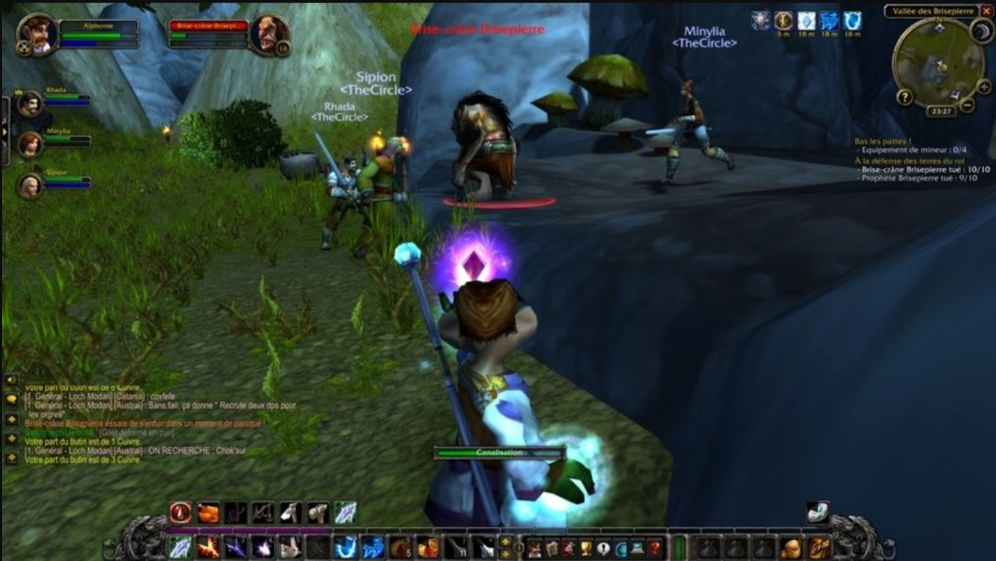

**Figure 2 World of Warcraft - screenshot**

* **Sports Games**

Sports video games encompass many disciplines such as basketball, tennis, football, etc. They allow you to play as an athlete or as a team of athletes. The objectives of a sports game are to represent as closely as possible the reality of the chosen sport and to take up the principles of reality without its constraints, aiming rather at the spectacular side of the discipline.

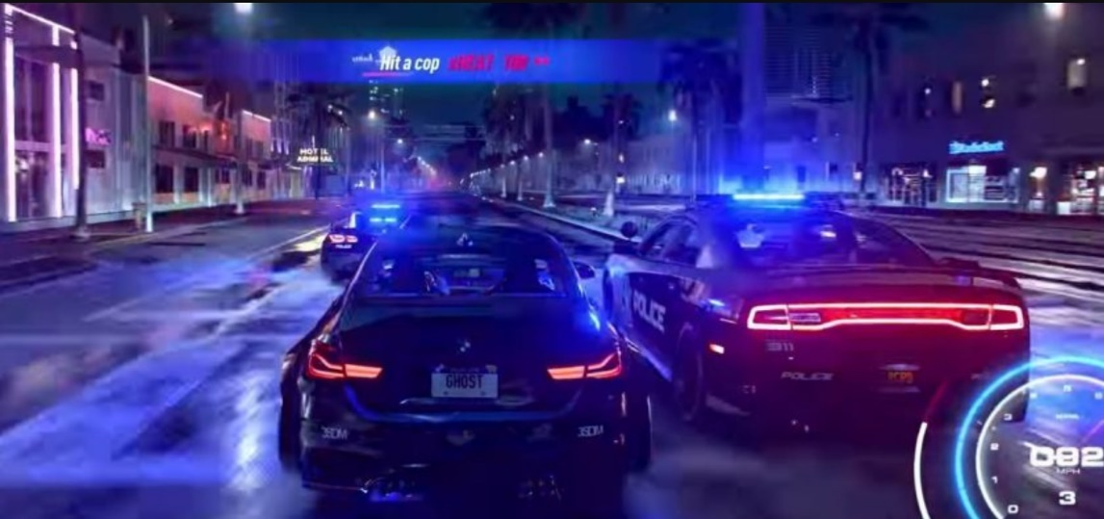

**Figure 3 Need for speed - screenshot**

* **Adventure games**

Adventure games are characterized by a focus on research and exploration, puzzle solving, rather than reflexes and strategies. The main objective is to tell a story like a movie or a comic book.

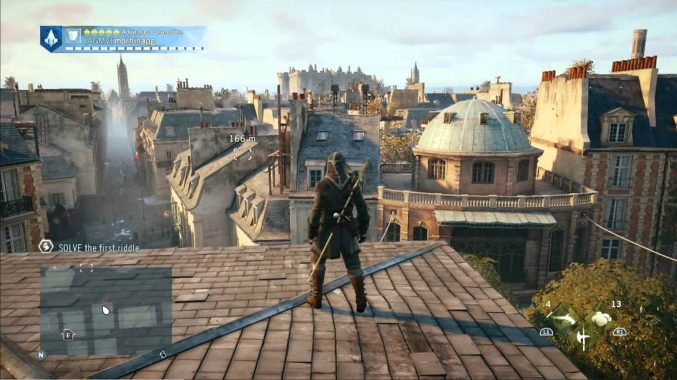

**Figure 4 Assassin’s creed - Screenshot**

* **First-person shooting games**

It is an often FPS action game subgenre for "First-Person-Shooter". This type of video game is based on combat in first person vision, that is, the player sees the action through the eyes of the protagonist.

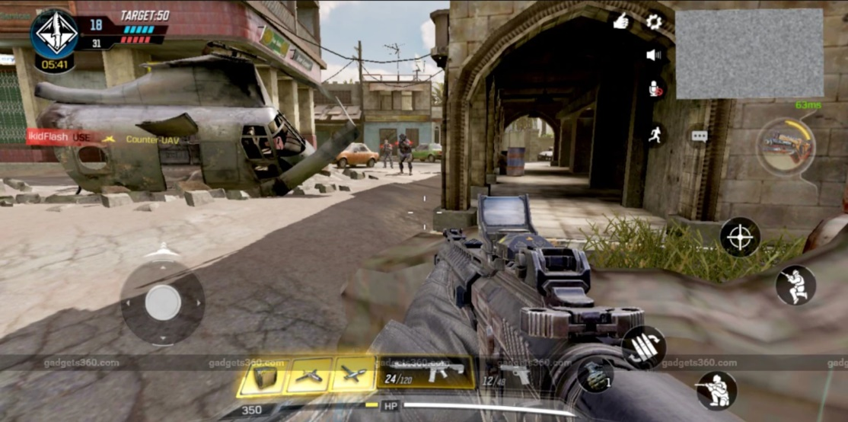

**Figure 5 Call of duty - screenshot**

* **MOBA games**

It stands for Multiplayer Online Battle Arena (MOBA), it is sometimes also known as Action Real-Time Strategy (ARTS). Essentially, the game is played between two teams of several players who choose a character from a roster of playable characters to level up and battle on a map with certain objectives.

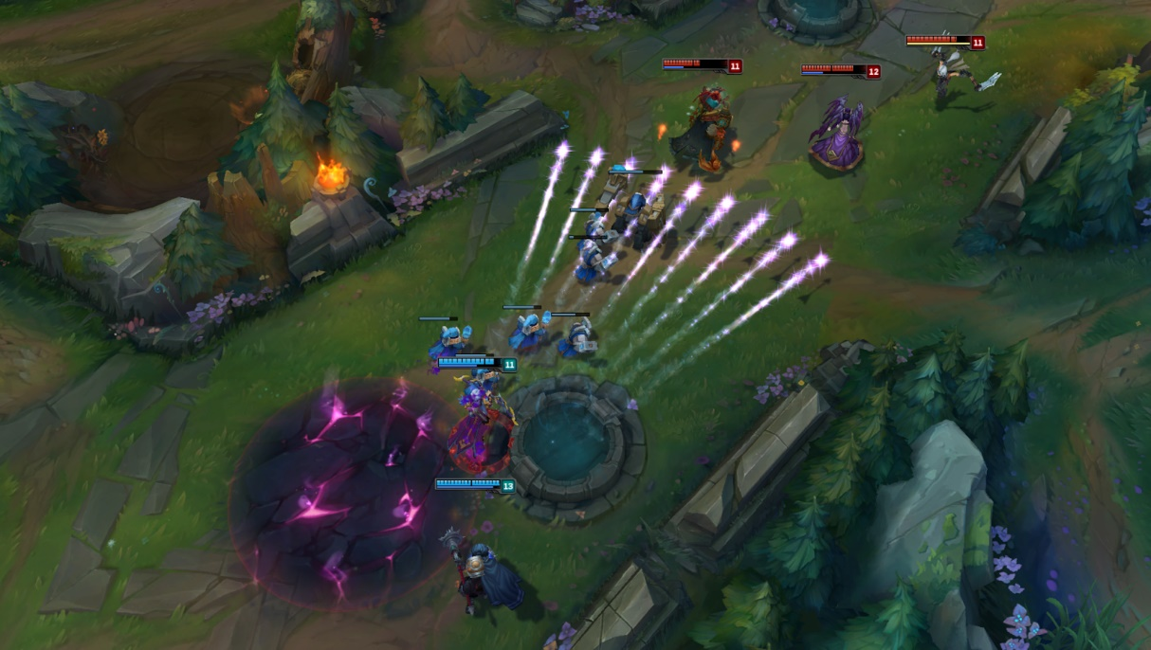

**Figure 6 League of Legends - screenshot**

* + 1. **Game modes**

In the context of video games, game modes are the different ways the user can choose to play. We can classify them into two distinct categories.

* **Solo**

In the field of video games, the term single player game refers to a game mode involving a single player during the game and only involves a single player during the game, the latter playing generally against itself or against the artificial intelligence managed by the game.

* **Multiplayer**

The multiplayer mode allows several people to participate together and simultaneously in the same game. This functionality can be achieved either by sharing the same hardware or in network play mode.

For the creation of our game, and after doing an analysis of the different types of video games, we chose to combine between the FPS, strategy, adventure and MOBA types.

1. **Concept and originality**

*Era’s end* is a video game designed to entertain and amuse gamers. Besides the points’ distribution by the leader gives the privilege to play with a strategy and always get an unexpected ending. Not to mention the non-violent fighting style (melee) and the items on the map that gives both teams the opportunity to turn tables at any time.

1. **chronogram:**

A Gantt chart is one of the most popular and useful ways of showing activities (tasks or events) displayed against time. On the left of the chart is a list of the activities and along the top is a suitable time scale. Each activity is represented by a bar; the position and length of the bar reflects the start date, duration and end date of the activity.

To summarize, a Gantt chart shows what has to be done (the activities) and when (the schedule).

There is no doubt that the Scrum method is the most famous and commonly used agile method in the current ecosystem. It is considered a structured and quickly deployable project management method.

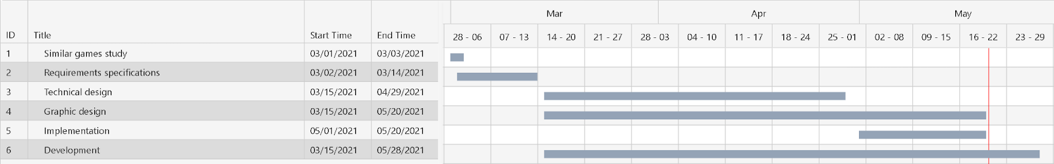

**Figure 7 Gantt chart diagram**

The Scrum method provides the possibility to control the progress of the project in an **iterative** form (more commonly referred to as a "**Sprint**").

The sprint lasts 1 to 4 weeks on average and is based on a specific goal:

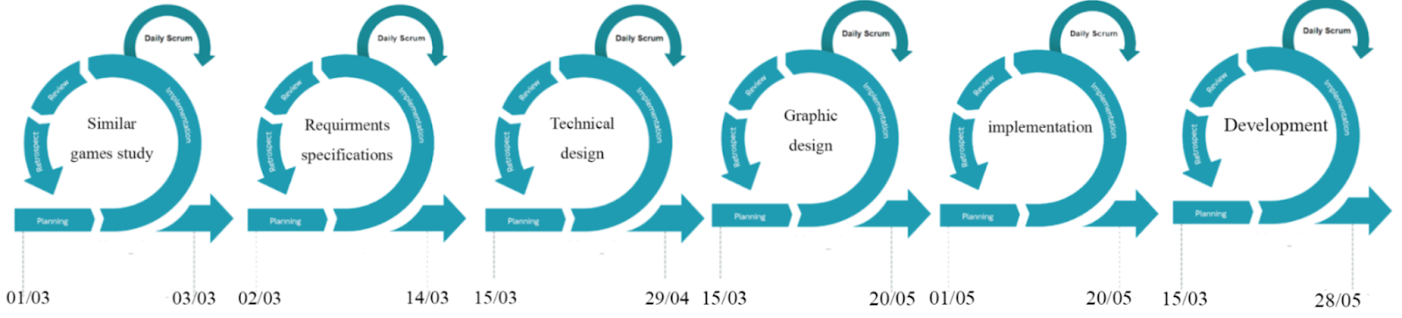

**Figure 8 Scrum Sprints**

Chapter 2: Similar games

We cannot develop our first 3D first-person game without looking back and studying the similar ones.

In addition, in order not to get lost in this vast field, we must first limit ourselves and set a goal. The choice fell on world-famous games that have been on the market for a decade at least and others that are quite new.

The first analysis is based on one of the iconic games of the genre: ***Counter-Strike: Global Offensive***.

Then, the next paragraph is devoted to the analysis of ***Apex Legends***: a relatively new shooter game with new gameplay mechanics.

To conclude, this chapter will include an analysis of the game ***League of Legends’*** networking system.

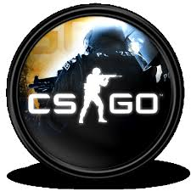

**Figure 9 League of Legends logo**

**Figure 10 CS:GO logo**

**Figure 11 Apex Legends logo**

* 1. ***Counter-Strike: Global Offensive***

|  |  |
| --- | --- |
| **Technical sheet** | |
| Description | ***Counter-Strike: Global Offensive*** (***CS:GO***) is amultiplayer first person shooter. |
| Version | Windows, Linux and Mac OS // PlayStation 3 // Xbox 360 |
| Publisher | Valve |
| Developer | Valve & Hidden Path Entertainment |
| Engine | Source |
| Genre | first-person shooter |
| Mode | Local multiplayer / Online multiplayer |
| Classification | +12 years |
| Release | August 21, 2012 |

* 1. **Scenario analysis:**

CS:GO is the fourth game in the Counter-Strike series. Developed for more than two years, "Global Offensive" was released first on PC, PS and Xbox almost a decade ago yet Valve will still update the game regularly, including smaller balance patches and larger content additions.

The game uses different goal-based game modes to set the terrorist and counter-terrorist teams against each other. The most common game mode involves terrorists planting bombs, while counter-terrorists try to stop the bombs.

There are eight official game modes, all of which have unique characteristics specific to that mode. The game also has a matching support function, allowing players to play on a dedicated Valve server.

* 1. **Game Play analysis:**

Like previous games in the "Counter Strike" series, "Global Offense" is a goal-based multiplayer first-person shooter game. The two opposing teams of terrorists and counter-terrorists compete in a game mode to repeatedly accomplish goals, such as ensuring locations where bombs can be placed or dropped, and rescuing or capturing hostages. At the end of each short round, players will be rewarded with in-game currency based on individual and team performance so that they can be spent on other weapons or tools in subsequent rounds. Winning games usually reward more money than losing them, and completing map-based goals (including killing enemies) will provide additional cash rewards.

1. **Apex Legends**

|  |  |
| --- | --- |
| **Technical sheet** | |
| Description | **Apex Legends** is a free-to-play hero battle royal game |
| Version | Windows // PlayStation 4 // Xbox One// Nintendo Switch // Android // iOS |
| Publisher | Electronic Arts |
| Developer | Respawn Entertainment |
| Engine | Source |
| Genre | first-person shooter // Battle royal |
| Mode | Online Multiplayer |
| Classification | +16 years |
| Release | February 4, 2019 for Windows, PS4 & Xbox One March 9, 2021     for Nintendo Switch E/A 2022   for Android & iOS |

* 1. **Scenario analysis:**

In "Apex Legends", up to 20 three-person teams or 30 two-person duos land on an island and look for weapons and supplies before trying to defeat all other players. As time goes by, the available game area on the island gradually shrinks, forcing players to keep going, otherwise they will find themselves outside the game area which may be fatal. The alive final team won the round. The game is in the same science fiction world as Respawn Entertainment's "Titanfall" and "Titanfall 2".

The game’s release in 2019 was surprising, because until then it had been assumed that Respawn Entertainment was working on the third instalment for the studio’s previous main game, the “Titan Fall” series. Apex Legends was well received by critics, praising its gameplay, progress system and the integration of various genre elements. Some people think it is a strong competitor to other Royal Royale games.

At the end of the first week, the number of players in "Apex Legends" had exceeded 25 million, and within the first month it exceeded 50 million. By April 2021, it will have about 100 million players.

* 1. **Game Play analysis:**

Each match generally features twenty teams of three-player squads. Before the match, each player on the squad selects one of the 16 playable characters (as of Season 8). Each character in the squad has a unique design, personality, and abilities that provide different playstyles to the team. All teams are then placed on an aircraft that passes over the game map and the team’s leader (randomly selected) chooses when and where to jump.

Once on the ground, the squad can scavenge for weapons, armour, and other equipment that is scattered around buildings, or in crates randomly distributed around the map.

*Apex* includes a nonverbal communication "ping system" which allows players to use their game controller to communicate to their squad certain directions, weapon locations, enemies, and suggested strategies which was the newest addition to this game genre and it was so great that most other games implemented the system shortly after its appearance in Apex.

Over time, the game's safe zone will reduce in size around a randomly selected point on the map; players outside the safe zone take damage and may die if they do not reach the safe zone in time. This also confines squads to smaller spaces to force encounters. The last squad with any members left alive is crowned the "Apex Champions" of that match.

1. ***League of Legends***

|  |  |
| --- | --- |
| **Technical sheet** | |
| Description | **League of Legends** is a free-to-play highly competitive global game with more than 200 million active players. |
| Version | Windows, OS X |
| Publisher | Riot Games Garena |
| Developer | Riot Games |
| Engine | Riot’s proprietary game engine (core: C++) |
| Genre | Multiplayer online battle arena |
| Mode | Online Multiplayer |
| Classification | +13 years |
| Release | October 27, 2009 for Windows March 1, 2013 for OS X |

* 1. **Scenario analysis:**

In the game, two teams of five players fight in a "player-to-player" battle, and each team occupies and defends half of their map. Each of the ten players controls a character with unique abilities and different game styles, called a "champion." In the competition, the champions become stronger by collecting experience points, winning gold coins and purchasing items to defeat their opponents. In the main mode of the game, "Summoner's Rift", a team wins by pushing toward the enemy's base and destroying their "Nexus" (large structure located in it).

The game is often considered to be the largest e-sports in the world, with an international competitive scene consisting of 12 leagues. The domestic league reached its peak in the annual League of Legends World Championship. The 2019 champion has more than 100 million independent viewers, and the highest number of simultaneous viewers is 44 million. Live streaming sites such as Twitch, YouTube, Bilibili, and cable sports channel ESPN are all broadcasting domestic and international events.

* 1. **Game Play analysis:**

*League of Legends* is a multiplayer online battle arena (MOBA) game in which the player controls a character ("champion") with a set of unique abilities from an isometric perspective.

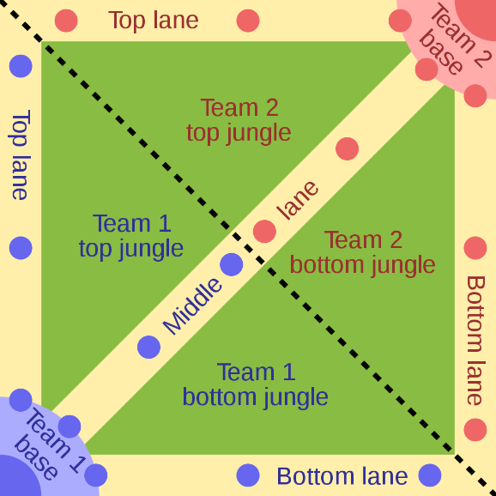

**Figure 12 Isometric Battle Arena**

As of April 2021, 155 champions can participate in the competition. In the course of the game, the champion gains experience points (XP) by killing enemies, thereby gaining levels. Items also increase the strength of the champion and are purchased with gold. Over time, players will passively accumulate gold coins and actively make money by defeating the opposing team's minions, champions or defensive structures. In the main game mode (Summoner's Rift), items are purchased through the shop menu, and the shop menu is only available to the player when the player's champion is in the team base. Each match is discrete; levels and items will not be transferred from one game to another.

1. **Inspiration syntheses**

As gamers that have played these games for a long time, programmers that enjoyed tackling problems and creating our own small things: these traits is what inspired our team to have a game as our project and these games is where we found our most inspirations.

* We chose the perspective to be “first-person” (like Apex or CS:GO) because of how immersive it tends to get. Having the player see the world of the game from the same angle as the character he’s controlling feels like actually being there and doing what the character does.
* Using a simple locomotion pack as eight directional movement and a sprint, it helps the players learn the game very quickly and leaves room for the dedicated ones to fully master it.
* Adding small side objectives like collecting hidden items, avoiding traps and exploring the large map, a technique used in games like Apex and League helps tremendously to keep the players’ experience fresh and non-repetitive in each match.
* Our game depends much on strategic team plays thus having the ability to communicate with each other in-game using a “voice” or “text” chat is very important.
* All major competitive games have very strong restrictions on the player age because of how gruesome the gameplay tends to be and so we thought, let us remove this restriction by simply removing the “killing” part of the game so any child can hop in and enjoy the game without any disturbing scenes.

1. **Conclusion**

So many games are already out in the market, already dominating the gaming scene and make the competition barely possible specially for indie game developers such as our team. But even so, the gamers community is ever growing and hungry for new releases thus giving new games a chance to pop into popularity if it satisfies the masses.

Chapter 3: Requirements specifications

* 1. **introduction**:

Specifying requirements is an important and difficult step. It is used to define the contract aspect. It establishes the guidelines and constraints that applications must follow.

* Definition of adopted methodology.
* Languages.
* Definition of the work environment for both game development and website.
* Functional requirements.
* Non-functional requirement.
* Conclusion.

* 1. **Requirement analysis:**

2.1. Functional requirements

To get a better understanding of the game, we need to specify the needs of its main actors. Era’s End has one primary actor which is the Player, and one secondary actor that the game interacts with is the database’s Server.

But first and foremost, the Player needs a way to download the game and also, a way to create his account: and therefore, like every other online multiplayer game, Era’s End needs its own website.

**what the player should be able to do:**

* create an account on the website.
* download the game from the website.
* access the account information from the website.
* login from the game.
* start/join matches.

**what the Server provides:**

* robust and secure database containing players accounts and data.
* being up and running 24/7 with no significant delay or package loss.
* stable matchmaking system that does not disconnect in match.

**what the Game provides:**

* a clear, easy to use user interface (UI) with understandable messages and popups.
* a profile page containing the account’s details and match history.
* a champ select area where the players can prepare their character before the match.
* a leader board containing the top 10 players on the server depending on their personal level.
* a “training” page contains the rules of the game and a minimap of the arena.
* a waiting room presenting the ready players before the match starts.
* a minimal and simple in match UI to let the players focus on the game.

**what the Website provides:**

* authentication: register and login.
* profile page with accounts data and match history.
* a “Download the Game” button on the home page.

2.2. Non-functional requirements: Era’s End

To make the game better, it is essential to define the graphic, ergonomic, technical, security and modularity constraints.

**2.2.1. Graphic constraints:**

Quality and graphics are the main image of the game. Indeed, the first thing players notice is the graphics. The balance of shapes and harmony of colours should first attract the eyes. This is why every game must abide by its own graphics charter.

**2.2.2. Ergonomic constraints:**

Before anything else, the game UI must be simple, understandable and above all readable. In addition, the game must provide visual consistency and quick access to information. It is important not to forget to limit the overloading of the menus.

**2.2.3. Technical constraints:**

Programming in an object-oriented language is very important because it helps to organize and therefore the project is easier to manage. It is reusable and its method is more intuitive.

Also, the game must be cross-platform in order to benefit a large number of users, considering the capacity of the various machines on the market.

Then, it is essential to use the Lightmapping system for scene lighting, because it can present static light and very detailed shadow shapes.

**2.2.4. Security constraints:**

The registered user’s information is fully secure in a private database online. Also, the “sign in” and “sign up” methods use the PHP password hashing algorithm to apply a thicker protection layer on the player’s account.

Furthermore, the users can utilise the official website to manage their accounts: change the email or the password, whenever they feel threatened.

**2.2.5. Modularity constraints:**

*Sectional Modularity*: In order to avoid the risk of errors and to facilitate the programming of the game, it is necessary to write the game code in several independent modules.

Sectional Modularity is a form of modularity adopted in mass customization. Segmented modularization allows a set of components selected from a set of component types to be configured in any way, as long as these components are connected at their interfaces. Each component can have one, two or more interfaces to allow sequential addition of components. Lego bricks can show the most basic form of modularity. A seemingly unlimited number of items can be constructed from a set of Lego.

2.3. Non-functional requirements: Website

**2.3.1. Graphic constraints:**

Because the website is the first place the players need to visit to start their journey, it is necessary for it to be welcoming and intuitive: using high spirited colours and attracting images/animations.

**2.3.2. Ergonomic constraints:**

The players would need to register before anything else and so, the GUI and forms have to be easily accessed, well organised and fully comprehensible.

**2.3.3. Technical constraints:**

After consulting our industrial and university supervisors, we agreed to use the Laravel framework because of how easy it was to learn and how beginner friendly it was.

It helped us move forward very swiftly and keep our work well organised all the time.

**2.3.4. Security constraints:**

The Laravel framework provides excellent user’s data security using the built in Auth System. Registration requires a powerful password, a working email and a verification mail to fully activate the player’s account before he can launch the game. The Auth System provides password encryption security as well by hashing the input before saving them in the database tables.

**2.3.5. Modularity constraints:**

Model View Controller, which is popular as MVC, is a widely used model currently used for Web development purposes. It is popular in various major programming languages ​​today, such as Java, Python, Ruby, PHP, but the MVC model is widely used for web application development purposes on the ASP.net platform.

* 1. **Use case Diagrams**

The Use Case diagram defines the relationship between the system and its actors. Indeed, it gives a global view of the behaviour of the system.

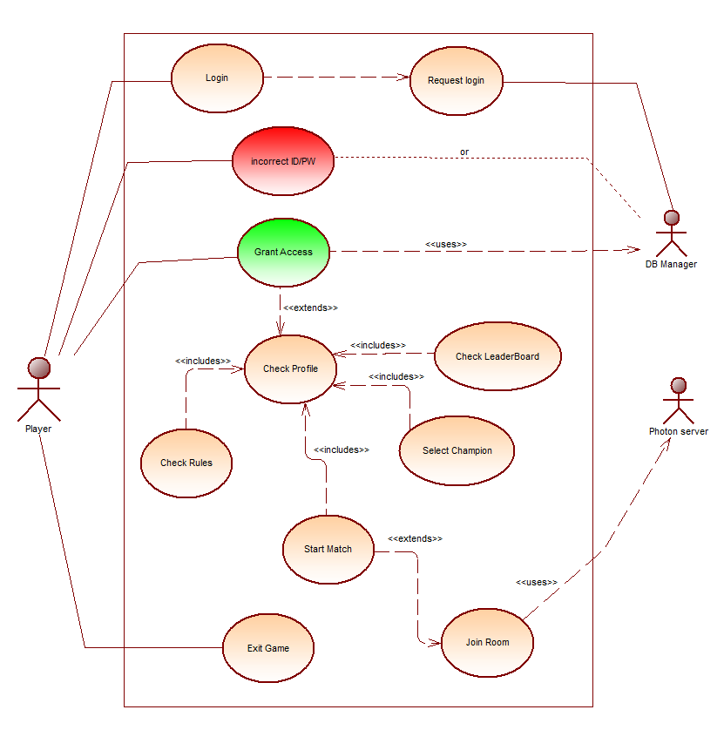

**Figure 13 Era’s End Use Case Diagram**

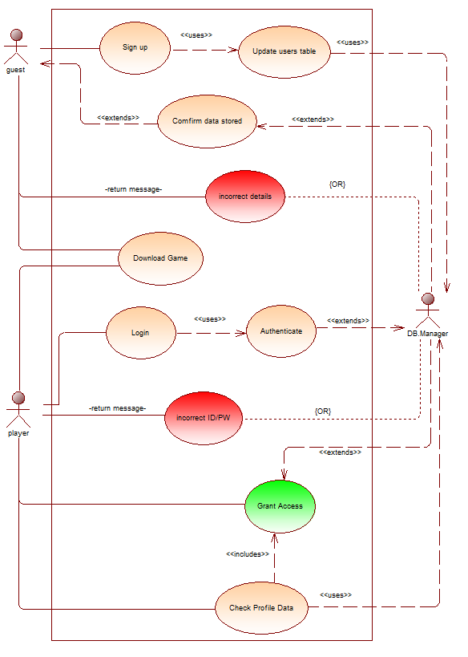

**Figure 14 Website Use Case Diagram**

2.2 **Textual Descriptions**:

After completing the use case diagram, it is very important to establish a text description of the use case. It makes it possible to clarify the progress of functions and describe the chronological sequence of actions that must be performed.

  As part of this project, the first text explains the "Authentication" phase of the game. Then, the other two elaborate on the “Select character” and "Start match" phase.

**Identification summary**

* Title: Login.
* Goal: Get access to <<Era’s End>>.
* Summary: The player must identify himself with his Username and Password.
* Actors: Player.

**Description of the sequences**

* **Preconditions:**
  + The player must have access to the internet.
  + The player must already have registered an account on the website.

* **Postconditions:**
  + The player signed in and gained access to the game.

* **Nominal chaining:**

1. The player enters their username and password in the provided fields.
2. The system verifies the authentication of the player's username and password.
3. The player is redirected to the interface which contains the main menu.

* **Alternative sequence N ° 2:**

Either the username or the password are incorrect or account logged in from another device)

1. The system detects the error in the provided data and deduces its type.
2. The game displays an error popup to the player with information.
3. The player is sent back to the login form to try again.

* **Description of HMI needs:**
  + Two input fields for ID & password.
  + Two buttons for submitting input data & cancelling the operation (quitting the game).
  + A popup with a comprehensible message identifying the authentication problem.

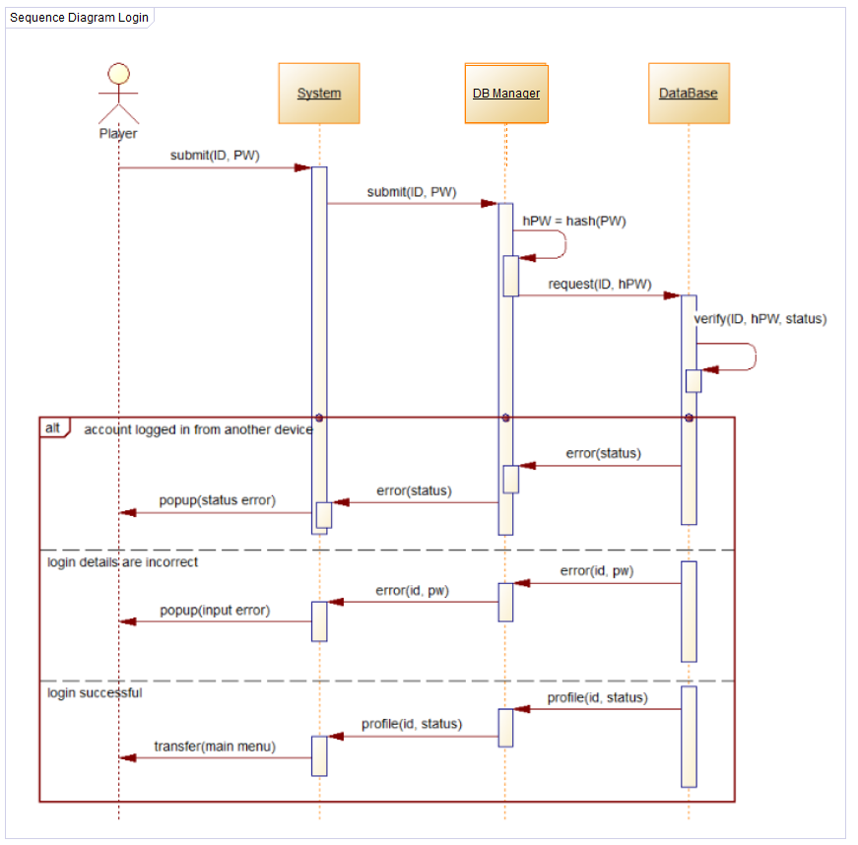

**Figure 15 Login Sequence Diagram**

**Identification summary**

* Title: Start match.
* Goal: start the gameplay.
* Summary: the game starts looking for open rooms, if there is none then create one and wait for additional players.
* Actors: Player.

**Description of the sequences**

* **Preconditions:**
  + The player must have access to the game.
  + The minimum number of players must be online.
* **Postconditions:**
  + The player joins a team and spawns in the Arena.
* **Nominal chaining:**

1. The player waits for the game to connect to the main servers as indicated on the UI.
2. The player can pick a character to play with as well as a cosmetic skin for that character.
3. Once the “Launch” button is revealed the player can start the matchmaking.
4. The game sends a request to the server for the “open rooms” list.
5. The game joins a random open room and assigns the player to a team.
6. Once the room completely fills up or the timer is up, the players are transported into the arena to start the match.

* **Alternative sequence N ° 2:**

1. The game finds an empty  “open rooms” list.
2. The game creates a new room and enlist it on the server.
3. The player joins the room, gets assigned to a team and waits for other players.
4. Once the room completely fills up or the timer is up, the players are transported into the arena to start the match

* **Description of HMI needs:**
  + The “Launch” button is greyed out until the game is connected to the server.
  + Six buttons with a display to indicate which character the player picked for the next match.
  + A “cancel” button if the player wants to stop looking for a match.

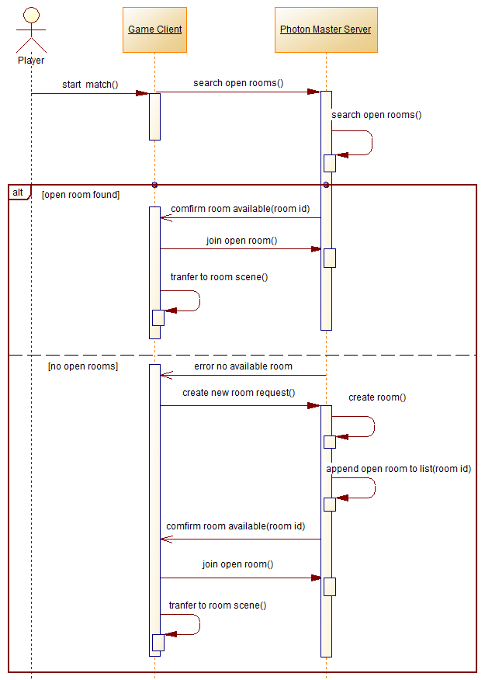

**Figure 16 Start Match Sequence Diagram**

**Identification summary**

* Title: Sign up.
* Goal: Create a new account.
* Summary: new users need to create an account to play the game later on.
* Actors: Guests (unregistered users) // DB manager.

**Description of the sequences**

* **Preconditions:**
  + The user must have internet access.
  + The user must have an email and have access to it’s inbox

* **Postconditions:**
  + The user’s new account is created and automatically granted access to the website’s features.

* **Nominal chaining:**

1. The user fills all the required fields accordingly.
2. The system verifies the inputs.
3. The user gets a confirmation email sent to their inbox.
4. The user verifies the email sent.
5. The user is redirected to the homepage where he can download the game or check/edit his profile details.

* **Alternative sequence N ° 2:**

1. The system detects the error in the provided data and deduces its type.
2. The webpage delivers a clear error message and guides the user to fixing the error(s).

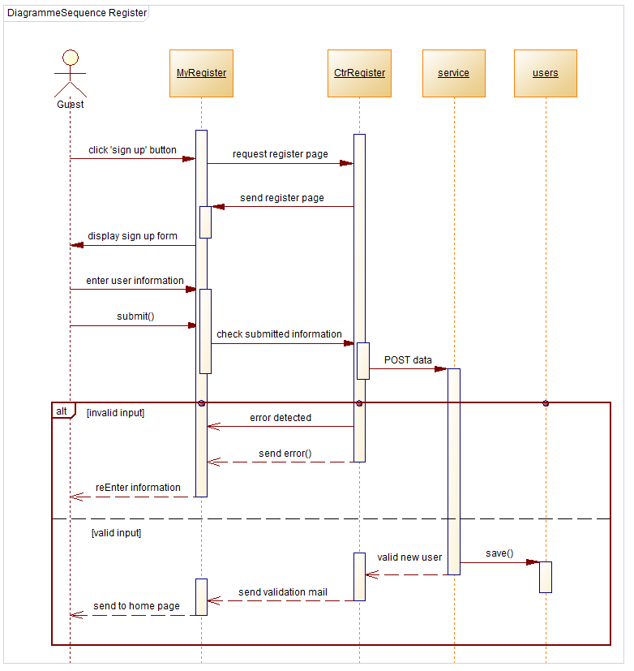

**Figure 17 Create Account Sequence Diagram**

**Identification summary**

* Title: Download Era’s End.
* Goal: downloading the game files on the user’s pc.
* Summary: getting the game files on the machine to play it.
* Actors: Guests **or** Registered users.

**Description of the sequences**

* **Preconditions:**
  + The user must have internet access.

* **Postconditions:**
  + The user will have the game ready to launch.

* **Nominal chaining:**

1. The user visits the website’s homepage.
2. The user clicks the “Download” button.
3. A popup with the terms and conditions & captcha appears.
4. The user checks the “i agree” checkbox and fills the captcha.
5. 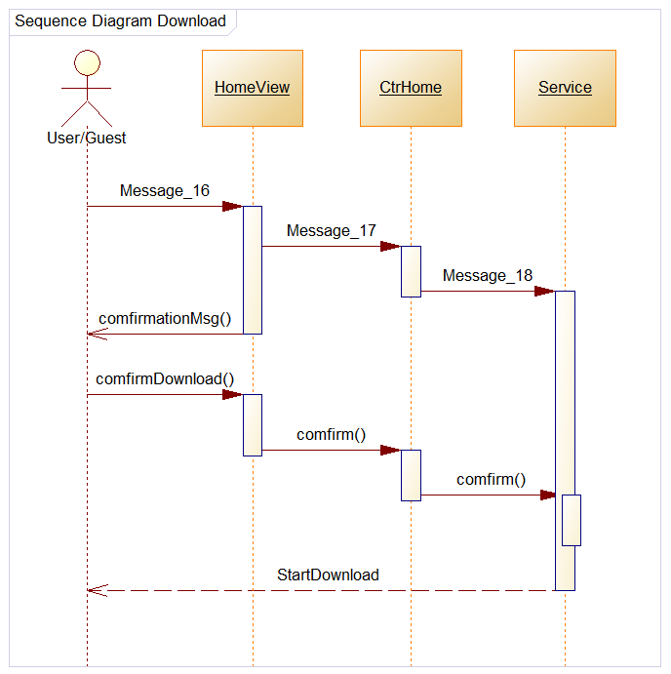 The website redirects the browser and automatically starts the download.

   Chapter 5 : Design

Design is a crucial step in a project's cycle as it describes its objectives visual and conceptual. This part will allow the development of a detailed project and a solid framework to facilitate its execution.

**1-Graphic design :**

**1-1  Synopsis :**

        - Goal: The first goal of a video game is leisure, then comes enhanced interaction, fantasy fulfillment, and stress relief. Era’s end is a game in which each player will be able to participate in matches.

               - Target customer: Our choice of not using violence in the game removes all age restrictions.

         - Context of use: It’s a game available on computers since the performance of PCs is much higher than that of consoles. They can even be increased further unlike the console.

**1.2. Scenario:**

      - Objective: Objective of the game Management is simple: Just pick an avatar, wait in the lobby for other players. Once the game starts the first player who gets in the lobby will be selected as the team leader. The leader will divide the points between all the team’s members. Then explore the map, search for items and accumulate points either by finding them in the map or by stealing them from the enemy’s team to thread the victories as there can be losses. Winning matches allows players to accumulate points to be able to level up. In addition, the player should garner a lot of success to Rank up.

         - Characters: Each player has to pick one avatar before starting the game.

         - Place: The game takes place in a foggy environment depicting flooded rural area in a post-apocalyptic/horror style.

**1.3. Navigation scheme:**

The choice was directly based on linear navigation, where the user has no other

choice than to browse the application in the established order.

This kind of navigation is very exploited in video games.

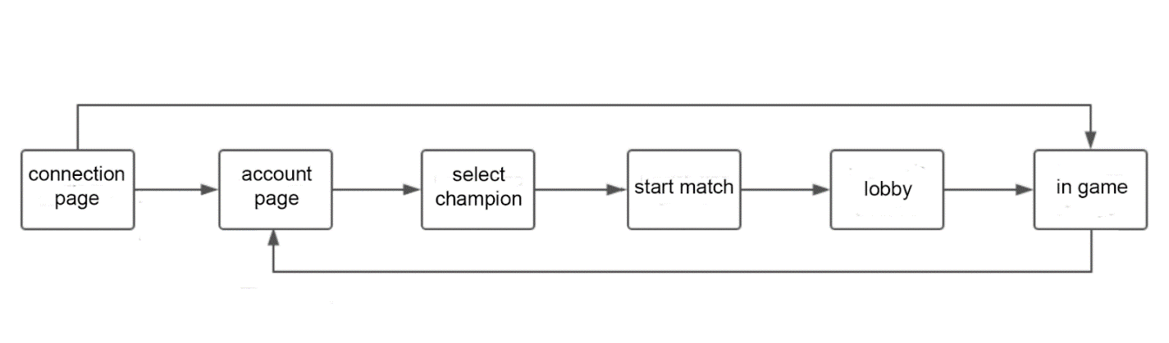

**1.4. Graphic charter:**

First of all, you have to specify the graphic charter because it is the basis of the game .

The main colors chosen for the game  are Crimson, Midnight blue, Turquoise. The crimson refers to this fairly bright pinkish shade of red which carries strong symbolism for both power and danger but also happiness and celebration.The midnight blue is linked with power, strength and intelligence. And for the turquoise it symbolizes compassion, clarity and communication.

The first plan contains the game’s interfaces; the login interface and the account’s interface. The login’s background should be attractive and gives a slight idea of the game’s elements such as the champions. For the account’s interface the background must be simple and dark so that the buttons would be more clear and the interaction would be easier. That’s why the first background contains three champions in the middle, a neon lightning in the back and the game’s logo on top. As for the second background it contains a reflected gradient using the midnight blue and plum ( a dark red purple) with a light and low opacity checkered.

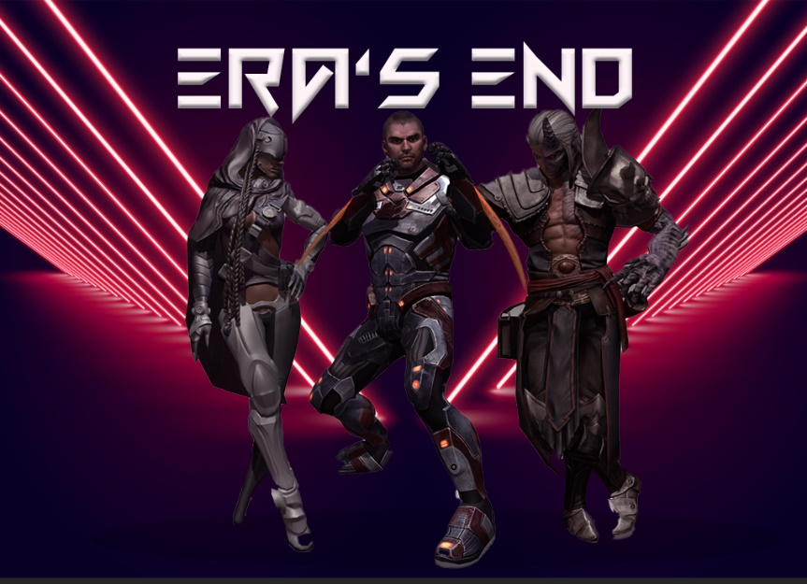

figure : login background



figure : account background

After several tests, the chosen fonts are strict and simple because they correspond with the intended target through the game.

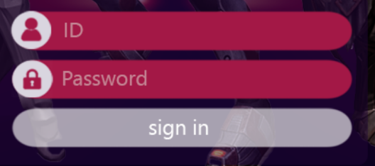

figure : chosen font 1

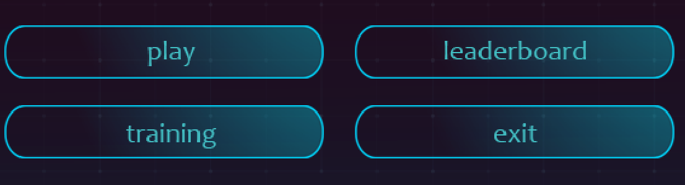

figure : chosen font 2

**1.5. Game’s logo :**

         The best type of logo for a game is Wordmarks (or the logotype) that way the name will stick in customers’ minds besides the name reflects the game’s story.

So in order to make the logo, we had to follow the graphic charter of the game. That's why we’ve chosen the color crimson . As for the font we’ve chosen “fun games”.



The game's interfaces are dark so the logo becomes invisible once you are included in them. For this, the idea was to change the color.





figure : in game logo

**2. Technical design:**

     The class diagram represents the system’s behaviour as a set of interactive objects..

To conclude, following the various parts previously studied, such as the study of the existing one, specification of needs and design, the project is finally ready for the final step which is realization.

Chapter 6: Realization

Before embarking on the realization of the game, it is necessary to take the time to cut out the project in tasks in order to plan their execution and to define the resources to be mobilized.

This chapter lists three main parts: graphics, technique and sound design.

**1. Graphic design:**

**1.1. UI Interface:**

Once decided on the details mentioned above. It was possible to start the creation of Game interfaces.

The graphics of these interfaces were made entirely with the software named "Unity" with the "UI" system and “Photoshop”.

For the login menu, the idea was to keep the champions in foreground for a 3D effect. As for the account interface it was divided into three main parts; the champion’s selection, player’s information and the menu.

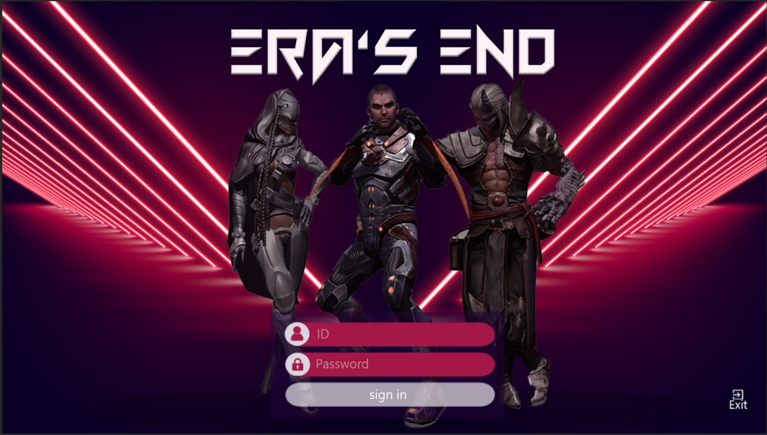

The login interface also has a button to exit



Once the login menu is passed, the user is in the account interface. This interface is divided into three main parts as mentioned above.

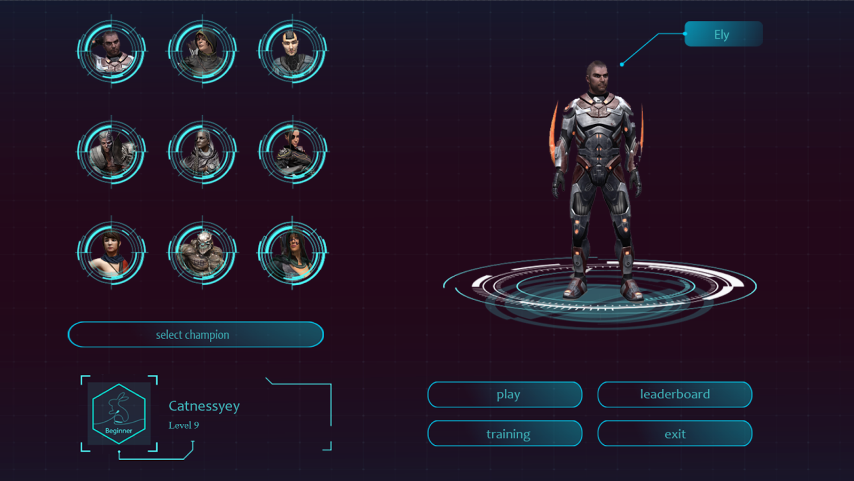

**champion’s selection :** All the 9 champions are presented in circular frames. Once the player clicks on any of them the champion will fully appear on the right. After picking the champion that he likes to play with, the player has to click on the “select champion” button.

**player’s information :** in this part the player will find his Id, his level in numbers and his rank. There are 10 ranks which are related to the player’s level.

level 1-10 : Beginner

level 11-25 : Apprentice

level 26-35 : Skilled

level 36-45 : Professional

level 46-55: Artisan

level 56-65 : Master

level 66-75 : Grandmaster

level 76-85 : Epic

level 86-100 : Legend

level higher than 100 : Mythe

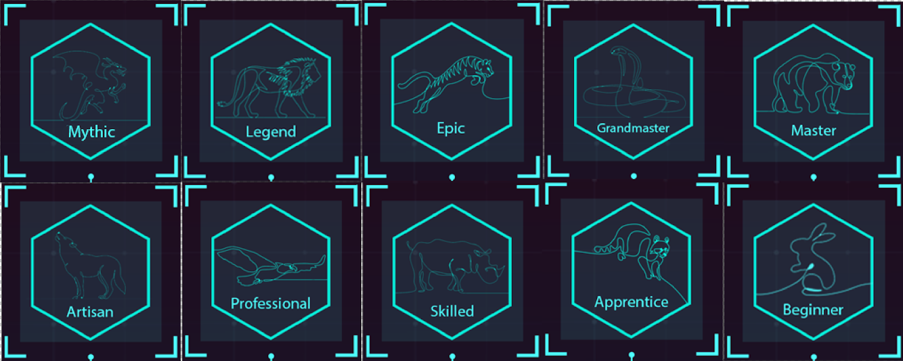

**menu :** In this part there are 4 buttons :

* Exit button
* Leaderboard when clicking on this button a board will pop up to show the 10 top players and the rank of the player himself.
* Training helps the player to know more about the game. It'll give him instructions on how to play and the rules of the game.
* Play button is active right after picking the champion, clicking on it will lead the player to the lobby where he’ll wait for other players to start the match.

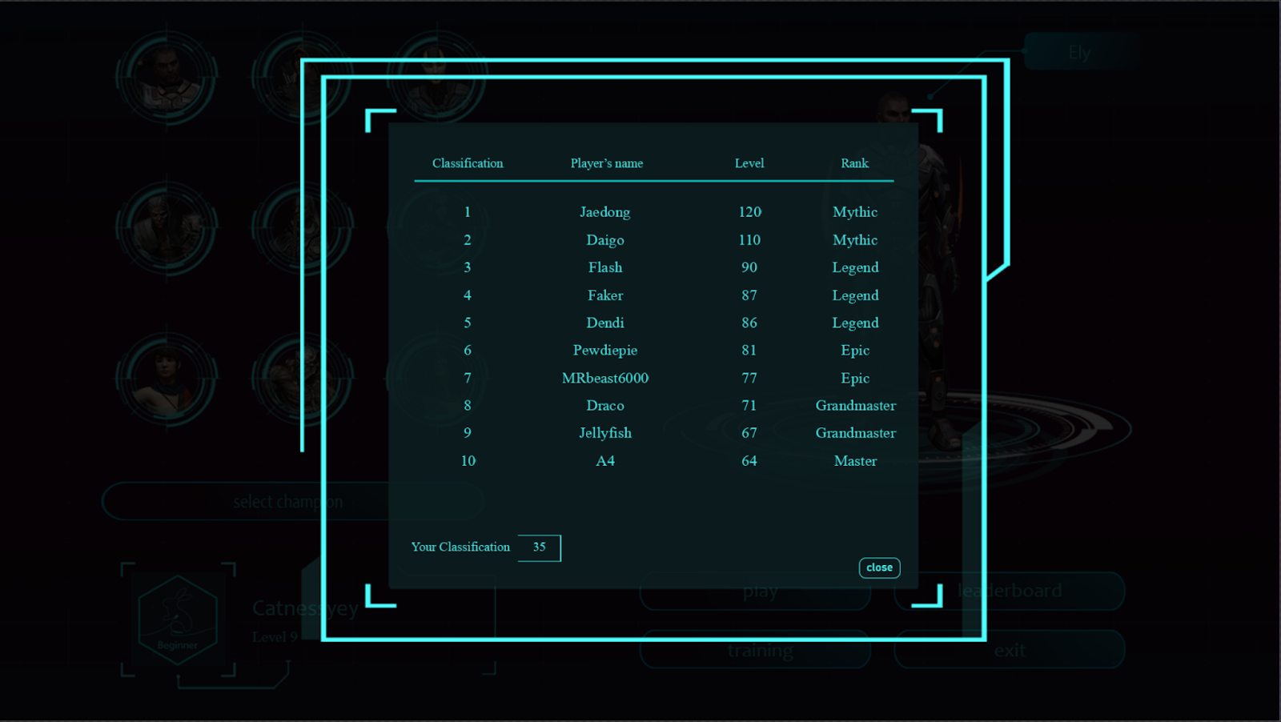

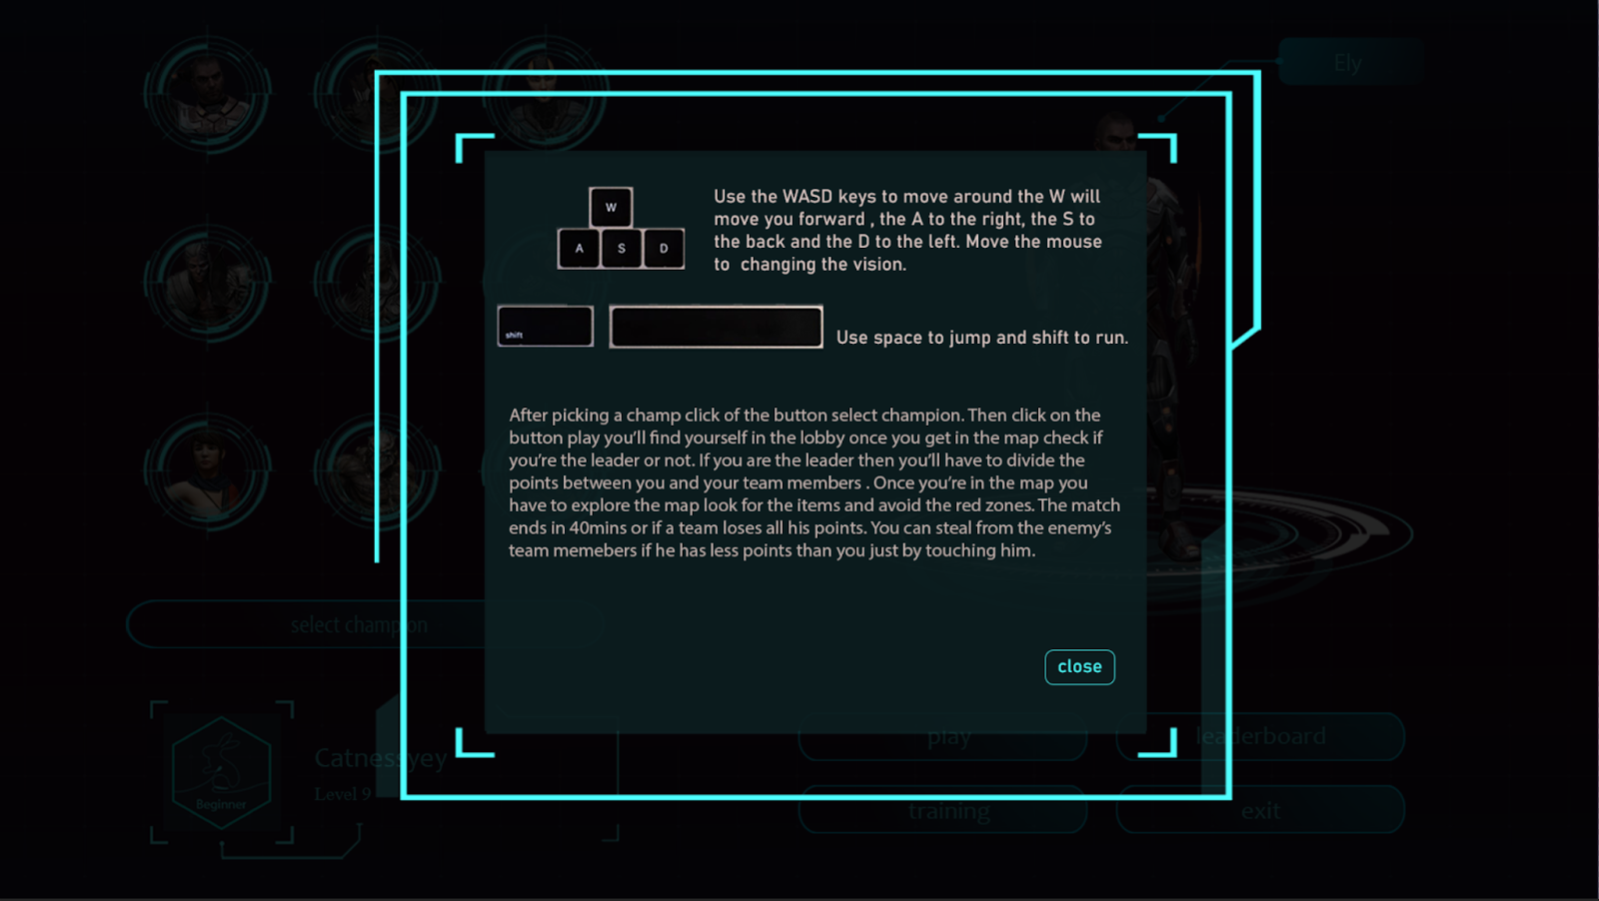

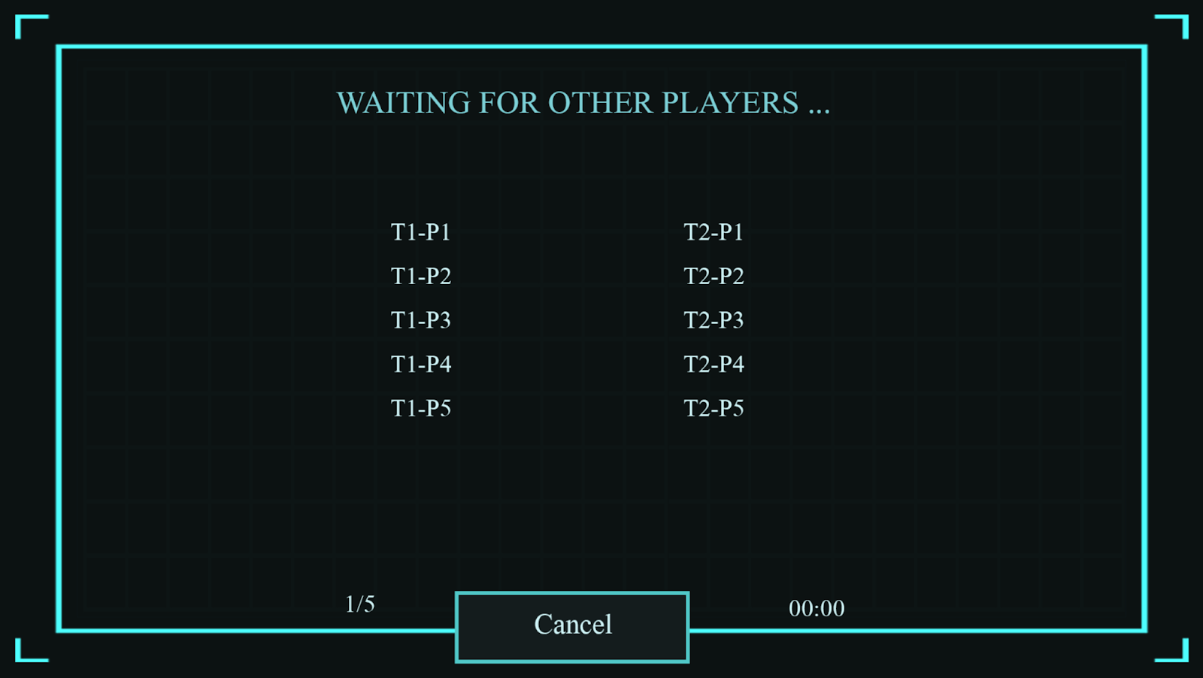

**1.2. Modelization :**

        One of the most important parts of the game that attracts the player is the game graphics (the map and the champions). Unfortunately creating superb assets will take at least 6 months and since we had only three months we had to search for some online assets that fit the theme of our game.

**Map modelization:** We downloaded all the map’s assets from the Unity store. Our map will consist of three categories :

**Buildings**; villas, cabins, barns, lighthouse, guardhouse, greenhouse, churches and structures.

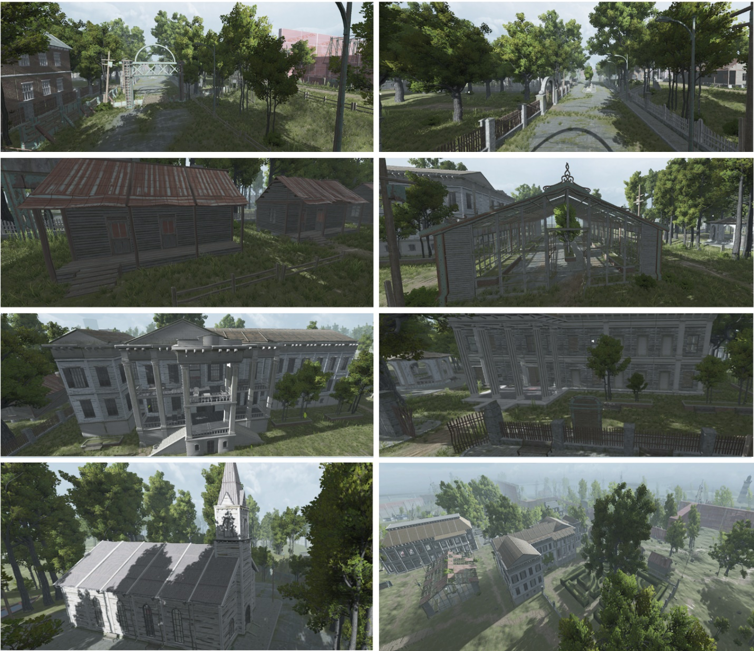

**Nature** ; trees, grass, rocks and bushes.

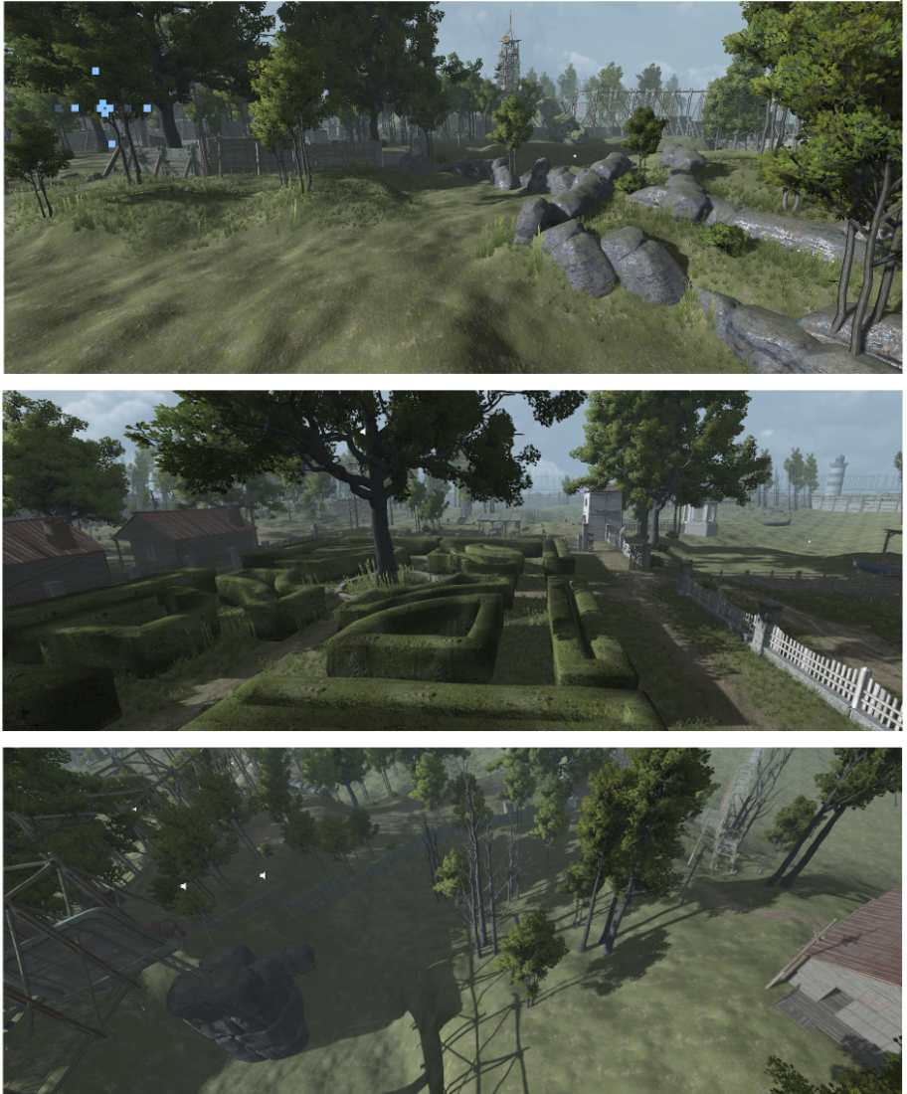

**Props** ; beds, cabins, chairs,lamps,tables, sofas, vases, paints, boats, clocks, cars and gravestones.

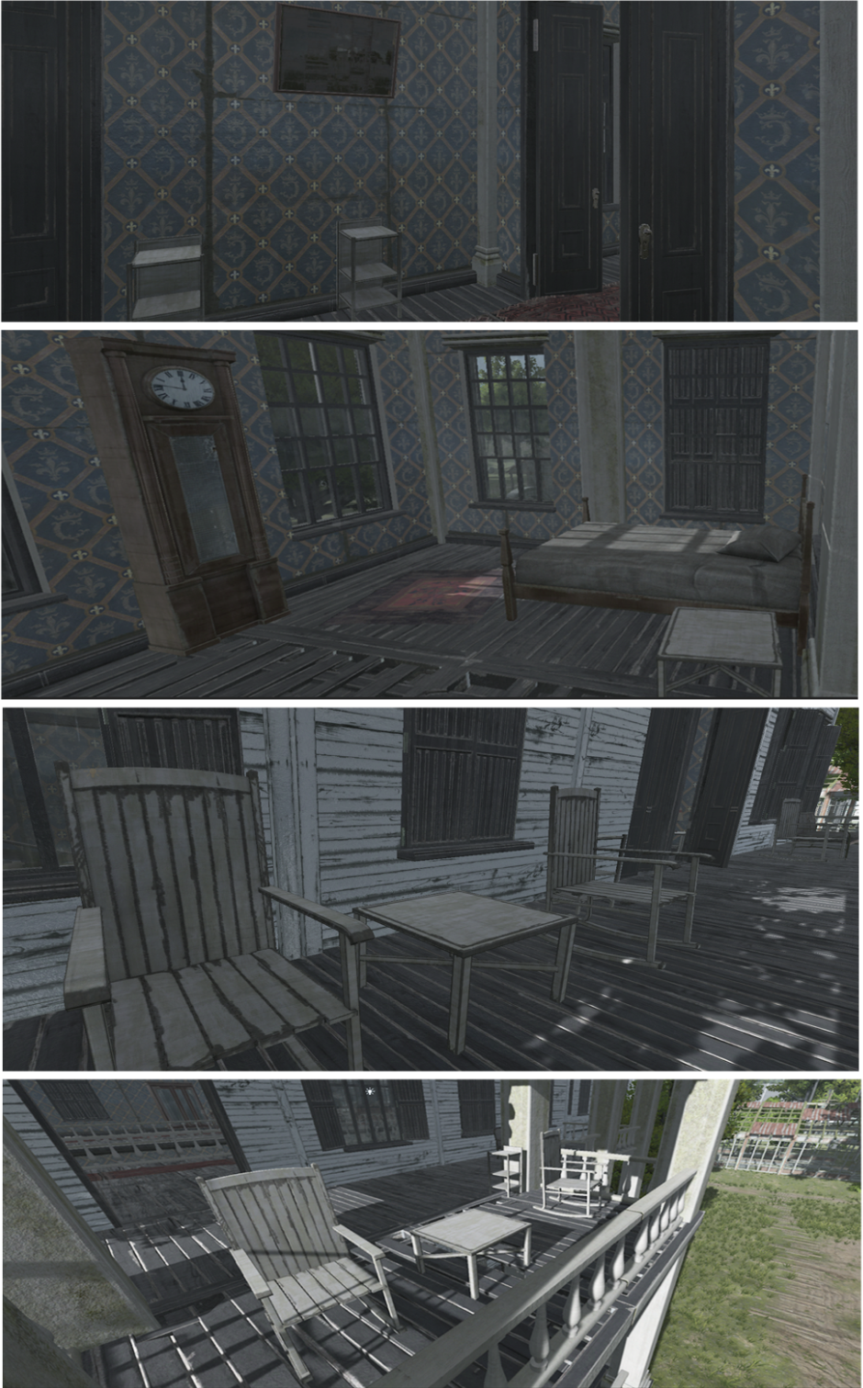

**Champions modelization:** For now, we have only 9 champions available. The champions have various looks so that each one can have his own story.

We have 5 female champions and 4 male champions. They’re all downloaded from Mixamo.

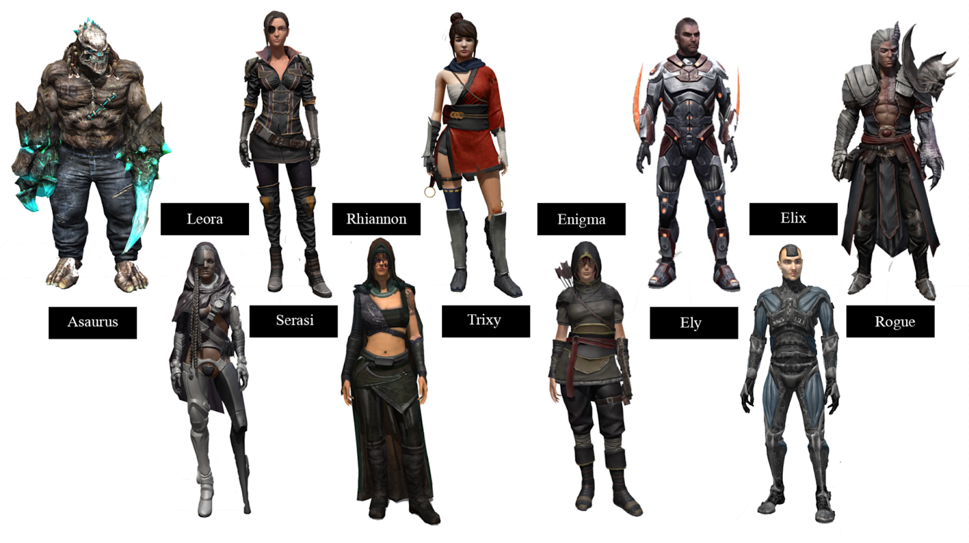**Items modelisation :**

We have 3 items that will be randomly located in the map: **extra points, shield and vision.**

The vision will be presented as a book that contains all the player’s points at that moment, the shield will be presented as a potion and finally the extra points it will be presented as coins.

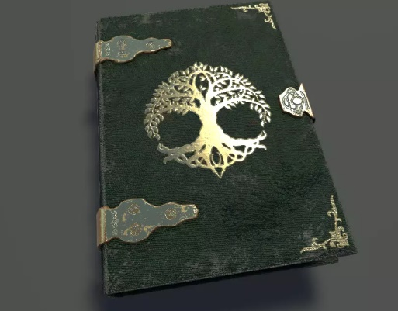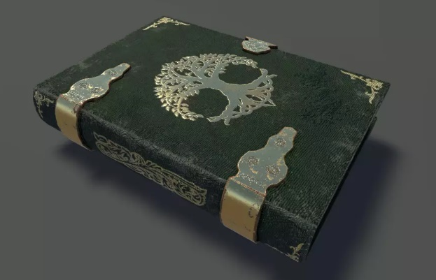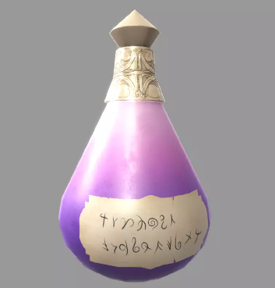

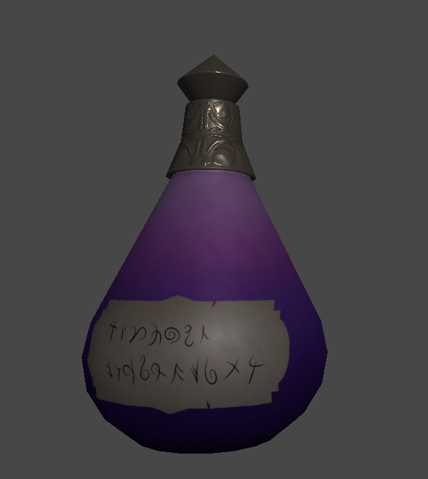

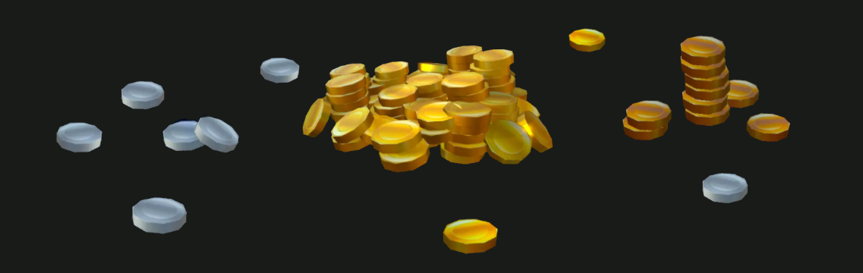

**1.4. Animation :**

The last step, in the realization of a 3D model, consists in “boning” and “rigging” the character, that is to say creating an animation skeleton placed in the modelization and adding controllers on this skeleton to animate it like a virtual puppet. In the Era’s end game, a champion requires 18 animations such as:

**Crouching**, **Jump**, **left turn**, **right turn**,etc.

**2. Technical realization**:

**1.1. Integration:**

To be able to integrate 3D models into "Unity", it is necessary to convert them to "FBX19" format.

This integration takes place in several stages:

- Import 3D models into "Unity"

- Import textures from 3D models.

- Import animations from “Mixamo”

- Select "Humanoid" as the type of animation in the "Rig" section

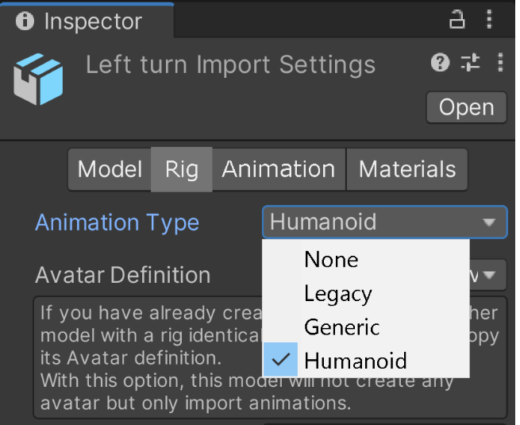

**1.2 Server:** Photon Unity Networking 2

Photon is a fast, streamlined and flexible real-time multiplayer game development framework. Photon consists of a server and multiple client SDKs for the main platform.

Photon Unity Network (PUN) is the basis of our advanced Unity-specific solutions: pairing, easy-to-use callbacks, components for synchronizing GameObjects, remote procedure calls (RPC) and similar functions provide a good start. In addition, it also provides a solid and extended API for more advanced control.

The complete source code is provided, so you can extend this package to support any type of multiplayer game you come up with.

The package is compatible with the hosted Photon Cloud service, which can run the Photon server for you. The setup window will register you in less than a minute (free of charge).

Most notable features:

* Easy to use API
* Lots of demos and an extensive [PUN Basics Tutorial](https://doc.photonengine.com/en-us/pun/v2/demos-and-tutorials/pun-basics-tutorial/intro)
* Server available as hosted service (free for development) or as "On Premise"
* Load-balanced! Scales across servers (with no extra effort)
* Outstanding performance of the Photon Server
* Dedicated servers. No NAT punch-through needed
* Offline mode: reuse your multiplayer code in single player game modes

**2.3. Development:**

**3. sound design :**

Music is the art of compiling sounds, it reinforces the visual feeling in the player, thus it allows him to dive into the world of the game.

All the sounds used in this project are of the “mp3” type.

The Era's end game includes background music and sound effects;

The choice of background music for the lobby fell on "Twisted Treeline" because it combines darkness, calmness and mystery that we have found adequate withthis game.

For the sound effects there are leaf rustle sound, water sound and wind sound effect.

**Conclusion and perspective**

This project was an important experience during which we were able to develop several skills and learn new techniques. Managing a video game project is not an easy task because it requires a lot of checking, research and testing to achieve an end result of acceptable quality.

Completing this project as part of a company was the other aspect of professional initiation and preparation for managing company expectations and user needs.

**Perspectives**

This work has reinforced our motivation to work in the field of video games. It also instilled our spirit of sharing and group.

We thus wish:

* Another game mode
* Character’s special abilities
* Another map